TestRail – Day 5: Test Runs – Assigning & Executing Test Cases
Date: 28-Jan-2026
Learning Objective
• To understand the concept of test runs in TestRail
• To learn how to assign test cases to a test run
• To execute test cases and record results
• To track testing progress using execution status
1. Test Runs in TestRail
Definition:
• A test run is an instance of executing selected test cases from one or more test suites to verify application functionality.
Learning Points:
• Test runs are used to track execution status
• Each run contains selected test cases
• Supports result tracking and reporting
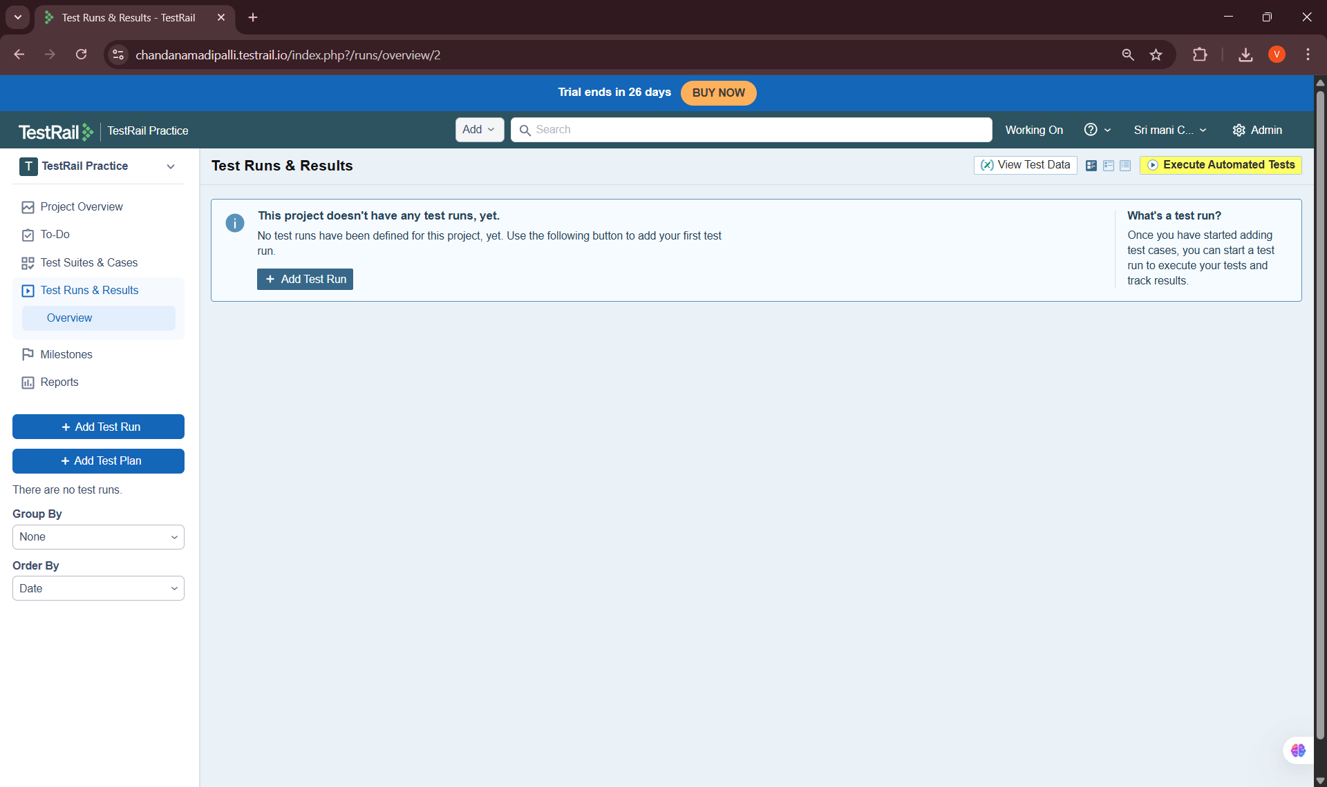
2. Creating a Test Run
Definition:
• Creating a test run involves selecting test suites and test cases to be executed for a specific testing cycle.
Learning Points:
• Created a new test run from selected suites
• Provided a meaningful test run name
• Defined the scope of execution

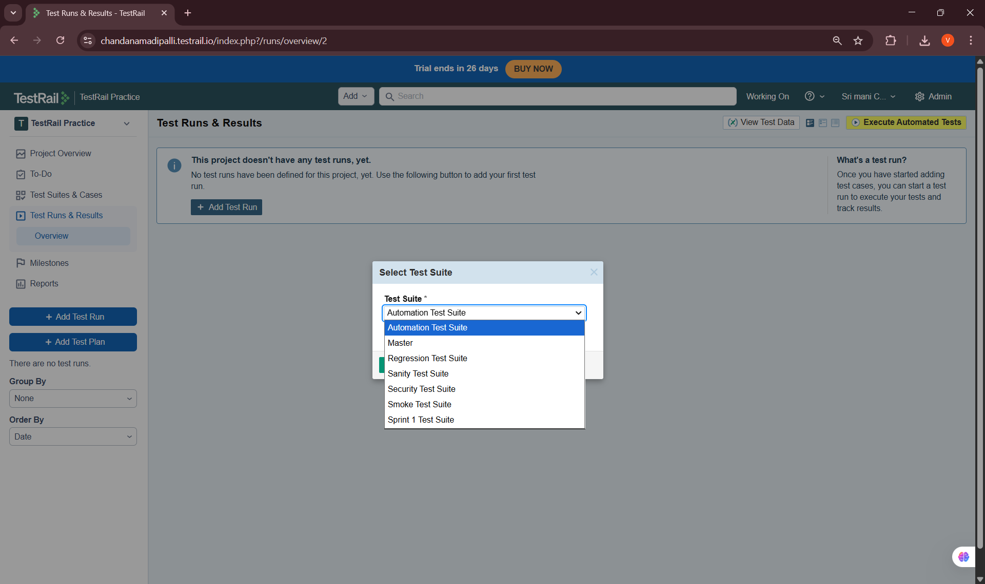
3. Assigning Test Cases
Definition:
• Assigning test cases means allocating test execution responsibility to specific testers or users.
Learning Points:
• Assigned test cases to a tester
• Used default and custom assignment options
• Ensured accountability during execution
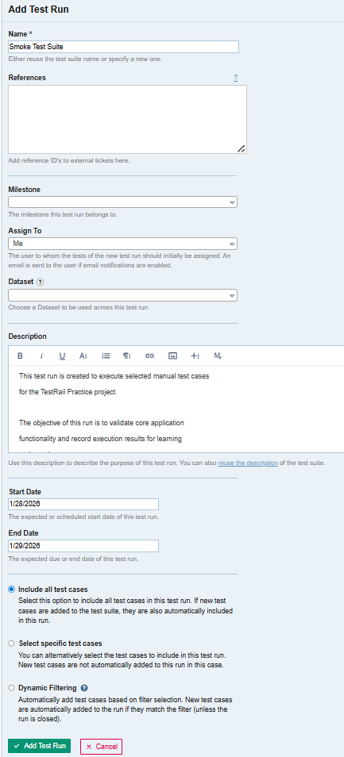

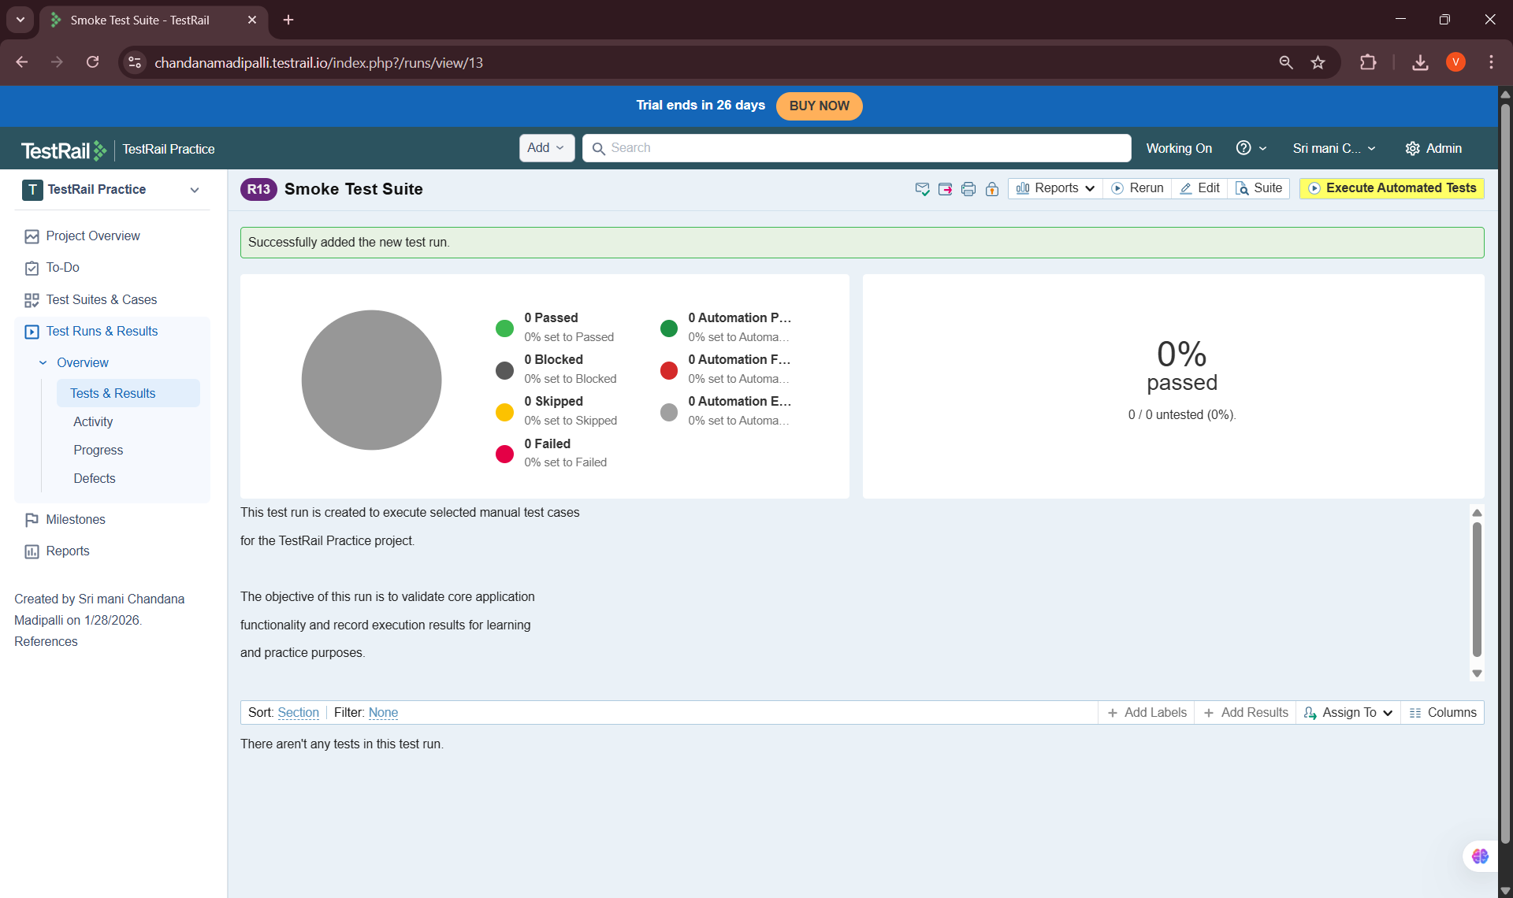
4. Executing Test Cases
Definition:
• Test case execution involves running test steps and comparing actual results with expected results.
Learning Points:
• Executed test cases step-by-step
• Marked execution status appropriately
• Added comments where required
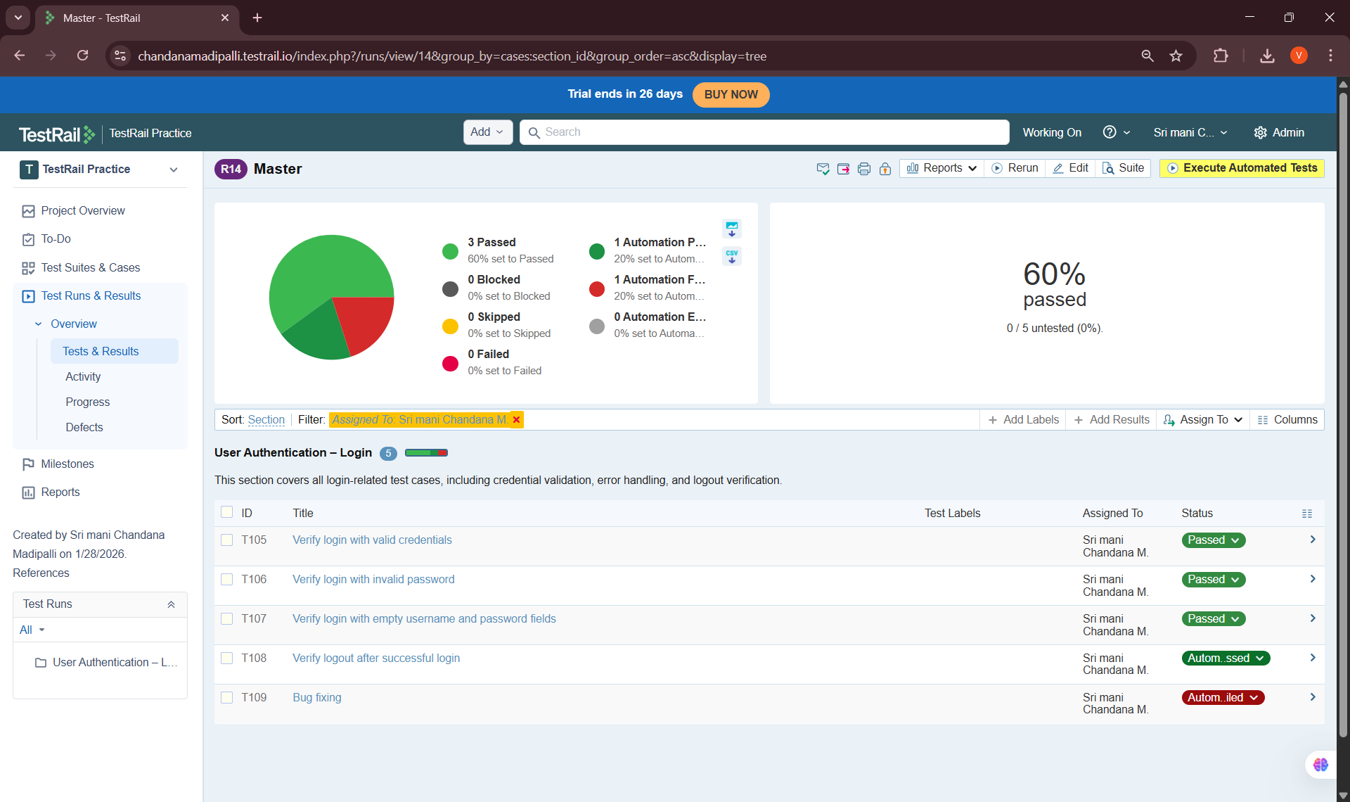
5. Execution Status & Tracking
Definition:
• Execution status indicates the outcome of a test case after execution.
Common Statuses Used:
• Passed
• Failed
• Blocked
• Retest
Learning Points:
• Updated execution status accurately
• Tracked overall progress of the test run
• Identified failed and blocked test cases
Key Learnings & Outcomes
• Understood the purpose of test runs in TestRail
• Learned how to create and manage test runs
• Gained hands-on experience assigning test cases
• Successfully executed test cases and recorded results
• Learned to track execution progress effectively

